### 

**CODE OF PRACTICE**

**WORK AT HEIGHT**



**ODISHA MINING CORPORATION LTD.**

**KODINGAMALI BAUXITE MINE**

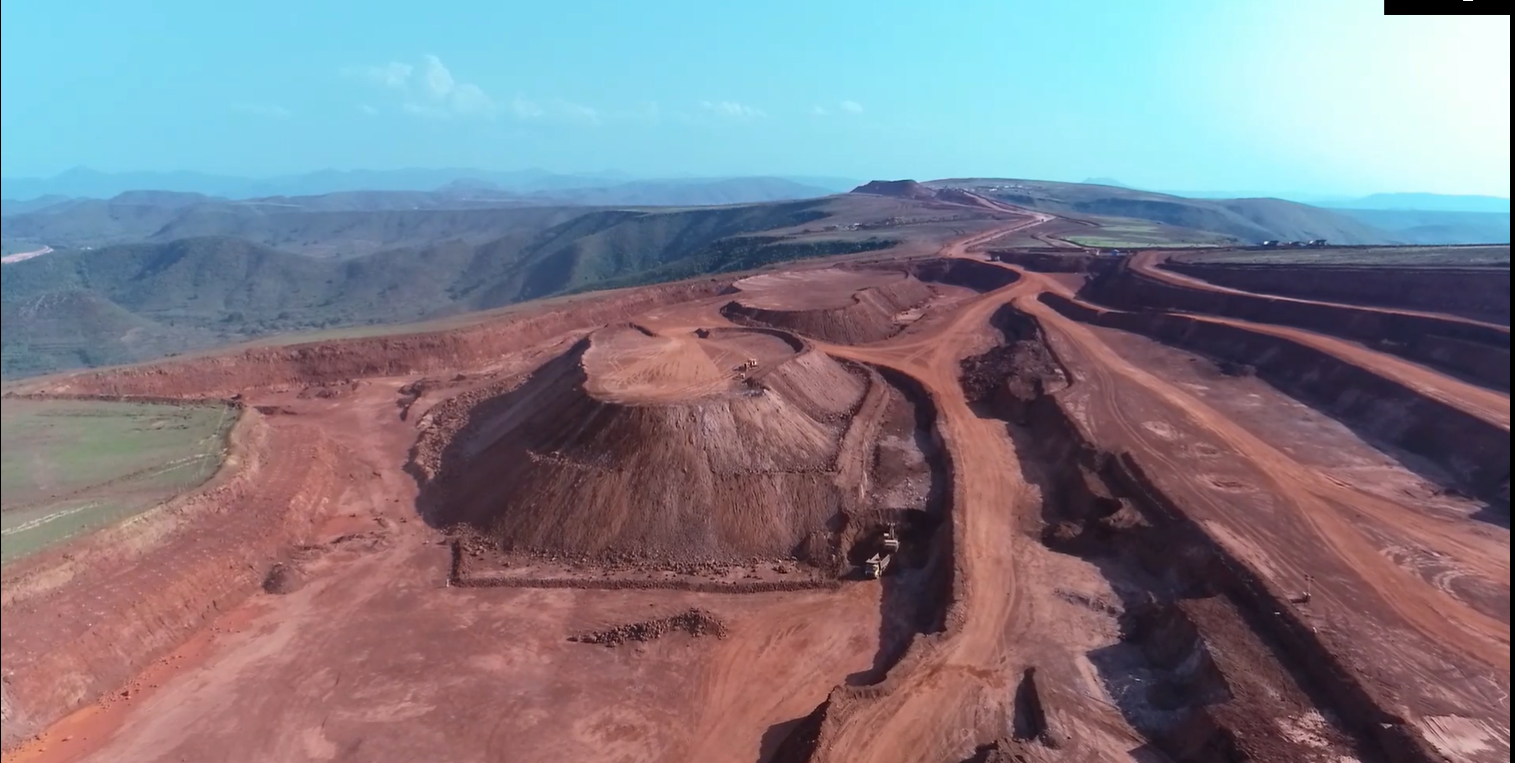

**Authorized By:**

### COP for Working at Height

**Purpose**: A **“Working at Height” standard operation procedure** establishes a safe working environment and system of work, also defining competencies, where personnel are required to work within 3 meters of an unprotected edge or from where they may fall from a height of 1.8 meters or more, in order to minimize potentiality of any injury to any person or any unplanned incident which may have potentiality to cause damage to equipment or property. The SOP lays down the guidelines, also incorporating stipulations as prescribed under the Metalliferous Mines Regulations.

Potential Risks involved whilst working at height could be –

* Fall of object onto persons below causing injury
* Fall of object onto structures, equipment, causing damage
* Fall of persons from height due to slip or overbalance, fatigue, strong wind, fear of height coupled with inadequate protection,.
* Failure of scaffold/platform or ladder

1. The work to be carried out shall be first reviewed following a structured risk-assessment process, applying standard risk-control hierarchy, and working at height shall only be resorted to with engineering & administrative controls coupled with use of PPEs, only if elimination or substitution of the process is not possible.

* **Elimination: Can the work be done at ground level by bringing the job down –**

e.g., bringing down the component to ground level for welding, or storing material at lesser height/accessible height

* **Substitution: Can the job be done from ground-level or using some equipment –**

e.g., use of long-handed tools, or use of fork lifts

**Responsibility: Manager, Safety Officer & Section In-charge**

1. A proper system of issuing of work permit with a site-specific and job-specific checklist shall be formulated and implemented for undertaking any work at height. The checklist shall, but not be limited to, include –

* Are people (supervisors & workmen) qualified/trained to carry out the job?
* Are workmen trained and have adequate experience to work at the required height?
* Are the workmen fit to carry out the job?
* Does the job call for medical certificate from the doctor for carrying out the work (fear of height in case height is more)
* What are the PPEs required for performing the job?
* Have they been provided for use by the workmen performing the job?
* Are appropriate signs required to be erected & have they been erected?
* Is ladder, scissor lift/hydraulic platform or ‘fixed platform over scaffold’ required to perform the job, and has such arrangement been provided?
* Are proper guard rails provided on movable/fixed platforms?
* Has proper access to the ‘fixed platform over scaffold’ been provided?
* Has the ladder, scaffolding/platform or other means to access to work-site been inspected & checked for its robustness/construction?
* Is ‘safety-net of adequate strength and design anchored immediately below the working place also required?
* Has such safety net been provided, and suitably anchored/stretched immediately below the working place, so that the risk of injuries to persons working at height is doubly ensured.
* Have full-body fall-arresting type safety harnesses of an approved type been provided in adequate numbers?
* Have the harnesses, their straps, safety line/life line, hooks, main load bearing metal parts & fittings, lanyards (double & not more than 3.0m in length) and anchor points of harness/safety-line/life-line been inspected and tested?
* Are there hazards other than fall of person or objects (like confined space, inadequate lighting, extreme heat/cold environment, strong wind, wet & slippery surface, etc.) also present and have adequate measures taken to eliminate, minimize or manage such hazards been taken?
* Is there any risk from falling objects?
* Have adequate measures been taken to eliminate the risk from falling objects ?
* Is edge protection required?
* If yes, what type of edge protection has been provided?
* Has the edge protection been duly inspected?
* Are there any overhead lines above or in the vicinity of the work-site?
* If yes, what precautions have been taken against risk of electrical shock?
* Whether all the measures have been duly inspected by the permit initiator and verified by the issuer?
* Any other matter and precautions taken.

**Responsibility: Manager, Safety Officer & Section In-charge**

1. Ladders of good construction, of requisite lengths, fitted with anti-skid pads & rungs are evenly spaced, portable/mechanized scissor-lifts and/or hydraulic platforms/scaffolds with guard rails & edge-protection, or scaffolding to construct fixed working platforms thereon with proper access to ascend & descend there-from, safety nets, safety lines/life-lines, etc. shall be provided in the mine for use whilst working at height.

**3.1** Proper PPEs in adequate numbers, required to work at height, like fall-arresting, full-body harnesses whose design, straps, lanyards, safety line/life line, hooks, main load bearing metal parts and fittings of the harness conform to IS 3521-1999, and harness/life-line/safety-line anchor points capable of withstanding a jerk-load conforming to IS 3521-1999 {not less 2000 Kg} shall be provided in the mine for use whilst working at height.

.

**Responsibility: RM/Agent & Manager**

1. Before commencement of such work, a site-specific & job-specific plan shall be framed by the official responsible or “**custodian**” of the job describing all systems, processes, procedures and safeguards to be undertaken to perform the work.

**Responsibility: Asstt. Manager, Mech/Elect. Engineer, as the case may be**

1. The “**Permit Initiator**” or the Mines Foreman/Site-Supervisor, who shall also be personally supervising the work shall, before initiating the permit, identify the hazards, assess the risks in consultation with the workers & if need be with the “custodian” too, conduct tool-box talks, ensure that only trained and experienced personnel are deputed, and arrange for measures required to eliminate, minimize or manage the hazards identified.

**5.1** He shall personally fill the site-specific/job-specific checklist, ensuring each of the points contained therein are factually answered and have been addressed in detail, ensuring that –

* Only trained, experienced, and fit persons are deployed to carry out and perform work at height, and also ensure that such persons carry a medical certificate from the doctor (against vertigo/ fear of height, etc.), if circumstances demand so.
* PPEs required for performing the job are provided in adequate number and that persons being deputed are trained in the use of fall arresting safety harness.
* The work-site is barricaded at ground level against inadvertent entry and caution boards are adequately displayed.
* The ladder in use is of requisite length whose rungs are evenly spaced, it is of good construction and is fitted with anti-skid pads.
* If scissor lift/hydraulic platform is to be used, its working height is commensurate with the job at hand and is fitted with guard rails and edge protection, and that it is in good working order (by raising & lowering the platform from ground level).
* If ‘fixed platform over scaffold’ is to be used, it shall be checked for its robustness and strong construction, the working platform is fitted with guard rails and edge protection, and that a proper access to the ‘working platform’ like walkway, stairs or ladder-way with hand rails to allow persons to ascend & descend has been provided.
* The guard rails and edge protection are inspected for their robustness and adequate construction
* A ‘safety-net of adequate strength and design is anchored/stretched immediately below the working platform, if so required, so that the risk of injuries to persons working at height is doubly ensured.
* The fall arresting, full-body harnesses, their straps, safety line/life line, hooks, main load bearing metal parts & fittings, lanyards (double & not more than 3.0m in length) and anchor points of harness/safety-line/life-line are inspected and tested. The design, straps, safety line/life line, hooks, main load bearing metal parts and fittings of the harness shall conform to IS 3521-1999 (reaffirmed 2002).
* The single person anchor points, life-line/safety-line anchor points are capable of withstanding a jerk-load conforming to IS 3521-1999 {not less 2000 Kg}.
* A mock rehearsal of coming down with the help of fall arresting safety harness shall be conducted if work to be performed is at a height of more than 5 meters.
* If there is any risk from falling objects, ensure that adequate measures have been taken to eliminate such risk.
* In case other hazards like confined space, inadequate lighting, extreme hot/cold conditions, strong wind, wet & slippery surface, etc., are also present, ensure that adequate measures are taken to eliminate, minimize or manage such hazards.
* If there are any overhead lines above or in the vicinity of the work-site, ensure that adequate precautions, including switching off of power, have been taken against risk of possible electrical flash-over/shock.

**5.2** He shall arrange for requisite PPEs, tools & tackles and other safety measures in case of any deficiency, confer with the “Custodian” in case the task is beyond his purview, and bring the shortcomings to his notice for intervention.

**Responsibility: Permit Initiator/Site-Supervisor**

1. The check-list presented by the Permit Initiator shall be reviewed and reassessed by the Custodian for hazard analysis and risk assessment including by site visit, to ensure that agreed control measures are in place, and proper tools and PPEs for the job are available.
   1. Competency of the persons being deputed for the work shall also be assessed through interaction with them as part of pre-operation check. SOP shall be explained to the workers and awareness amongst them shall be checked.
   2. A writtenpermit to work at height shall be issued to the Permit Initiator in the form and manner as prescribed by the manager, mentioning the date and time of issue and period of its validity, obtaining counter-signatures of the Permit Initiator.
   3. In case the work is to extend beyond shift end, adequate handover procedures at shift change shall be ensured.

**Responsibility: Asstt. Manager, Mech/Elect. Engineer, as the case may be**

1. The site-supervisor shall personally supervise the work so long persons are deployed at height, and shall not leave the site unless the work is and continues to remain suspended till his return.
   1. Every person permitted to work at height on a scaffold/platform or basket/bucket shall perform the task assigned in the manner as fixed by the site-supervisor & “custodian”, and they shall wear a full body fall-arresting harness of an approved type attached by a double lanyard (not more than 3.0m in length) to a suitable anchor points, life-line or safety-line.
   2. In case they are required to move, at-least one lanyard shall remain coupled to the anchor/life-line/safety-line, which shall only be removed once the other lanyard has been coupled to another anchor or coupled back to the life-line/safety line.

**Responsibility: Site-Supervisor, persons deputed**

1. Depending on the nature of hazards and risks involved, surprise checks shall be carried out to physically inspect the work-site and ensure that all work is being carried on in accordance to the SOP.

**Responsibility: Custodian, Safety Officer, Manager**

1. At the end of the work, the permit shall be signed off, mentioning therein the date & time, under the signatures of the site-supervisor and the custodian.
   1. Any shortcomings, slippages from SOP, and learning’s from the job shall also be captured on the permit at the time of signing off.
   2. A copy of signed off permit with remarks thereon shall be made over to the Safety Officer.

**Responsibility: Site-Supervisor, Custodian**

1. The work permits shall be regularly monitored for shortcomings & slippages from SOP as well as for the lessons learnt.
   1. The competency of site-supervisors and custodians shall be regularly assessed and monitored. A proper Work Permit book shall be kept maintained.
   2. A protocol, of periodical physical examination and testing of harness & lanyards, and of the safety net, and of conducting a mock rehearsal of effective rescue ~~at~~ from height, mentioning names and designations of persons involved, at intervals not exceeding 3 months, shall be established and a record thereof shall be kept maintained.

**Responsibility: Safety Officer, Manager**

****************